Would you feed your dog caviar? The rise of Michelin doggy dining and other extravagant canine treats

At £50 a tin, 'dogviar' is a pricey treat. But it's just the beginning of a whole world of lavish canine living
ByBen McCormack18 April 2021 • 6:00am
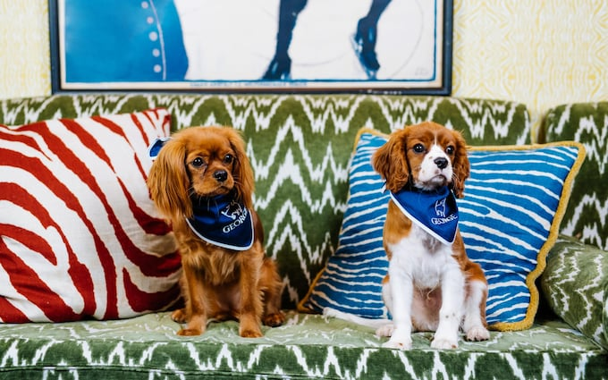
Two dogs hanging out at George
​I sometimes wonder if my career choice of restaurant writer can be traced back to the mid-1980s and feeding the family dogs the offcuts that my mother rustled up instead of pet food. Brains and tripe has, to my mind, always seemed infinitely more appealing than Angel Delight.
Our Airedales’ offal-based diet might have anticipated gastronomy’s nose-to-tail movement by a good 15 years but we may soon all be making our own dog food. The huge growth in lockdown dog ownership has left Britain on the brink of a national pet-food shortage.
And yet with the cost of a puppy doubling over the past 12 months – Cavapoos, the most in-demand breed, now command a price tag of almost £3,000 – the concept of a dog treat is taking on an ever-more extravagant meaning.
This summer, Exmoor Caviar is launching Dogviar, which at £50 per tin may possibly be the world’s most luxurious dog treat yet. The made-to-order canine snack is kibble coated in a patented mix of caviar oil and caviar protein, which, Exmoor says, equates to around 30g of traditional caviar per 100g of Dogviar.
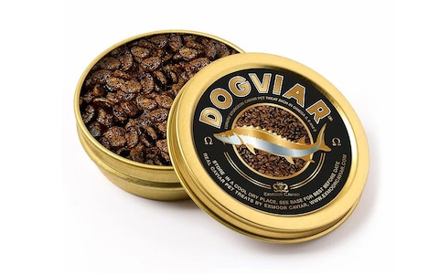
Dogviar, from Exmoor Caviar
In the interests of investigative journalism, and mindful of the fact that all ingredients used for pet food must be fit for human consumption, I submitted the Dogviar to a taste test. The flavour is not unlike a bag of Scampi Fries and would be terrific paired with the iodine tang of an Islay single malt. My four-month-old Cockapoo Barney wolfed it down, which is likely to be a recipe for disaster the next time I try to bribe him with a pig’s ear.
You don’t need to treat your pup to caviar, however. Paul Ainsworth, the chef behind the Michelin-starred No 6 Padstow, recommends chopping up some Heck chicken sausages (“healthier and leaner than pork”) and stirring them through scrambled free-range eggs. Now that really is a dog’s breakfast.
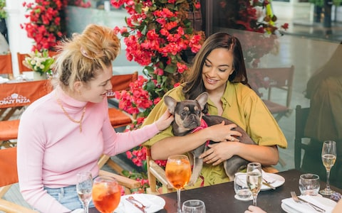
Crazy Pizza is a popular dog hangout CREDIT: lateef.photography
Ainsworth says that space restrictions are the only thing stopping him admitting dogs to No 6 but mutts are very welcome at his Rock pub The Mariners, where there is a station full of dog treats and bowls of water.
And what could be better for socialising lockdown pups than introducing them to the joys of restaurant-going –especially if, like James Middleton, puppy love helps you meet the love of your life? Dogs at Islington’s Bellanger and Knightsbridge’s Crazy Pizza are served a plate of biscuits to munch on.
But why stop there? M Victoria St holds a weekly Six-Legged Brunch on Saturdays (£35) with shakshuka, steak and eggs and a pancake stack for humans, and chicken jerky, biltong risotto and peanut-butter cookies for dogs. Good luck getting your pooch to share any of that.
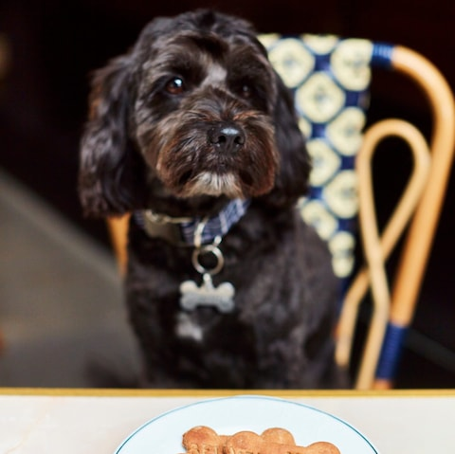
A dog enjoying treats at Bellanger
Or take out a membership at George, part of the same stable of Mayfair clubs as Annabel’s and Harry’s Bar. The George Dogs committee, which includes the likes of David Gandy, Carole Bamford and Yasmin Le Bon, oversees all aspects of canine comfort, from beds and bowls to doggy menus and regular events to raise money for dog charities.
This year’s focus on staycations, meanwhile, means there is no imminent need to take out a pet passport when your pooch can holiday in the UK. Paul Ainsworth’s boutique Padstow Townhouse welcomes dogs with your pet’s name written on homemade gingerbread biscuits, dog beds and bowls (rooms from £245 plus £25 per dog per night).
Four-legged visitors to Gleneagles, meanwhile, are made to feel at home by the hotel’s resident Golden Labrador, Henry, who can entertain your pet while you kick back with lobster rolls and vintage Moët on the Glendevon Terrace (rooms from £400 plus £100 per dog per night).
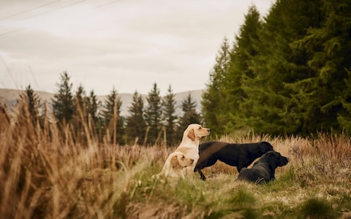
Gundogs at Gleneagles
For the ultimate in hands-off dog care, The Lanesborough’s team of private butlers can take your pooch for a walk in Hyde Park. Back inside, dogs receive a personalised welcome card and snack upon arrival and once they’ve eaten their own meal of beef sausage and slow-braised chicken, four-legged guests are welcome to join their owners for a post-prandial snifter in the hotel’s Library Bar (from £615 per night).
You will, of course, want your dog to be dressed appropriately. Hermès’ collars and leads (from £510) are made from the same bridle leather used in equestrian accessories (and thus are sturdy enough to withstand chomping). Should you ever let them off the luxury lead, an Hermès-branded frisbee made of recycled natural fibres is just the thing to teach them fetch (price on application).
Louis Vuitton and Goyard likewise impress with dog accessories which befit their venerable histories as leather-goods manufacturers, but the dernier cri in canine couture goes to an American start-up called Pagerie, which bills itself as ‘the first ultra-luxury fashion house for pets’.
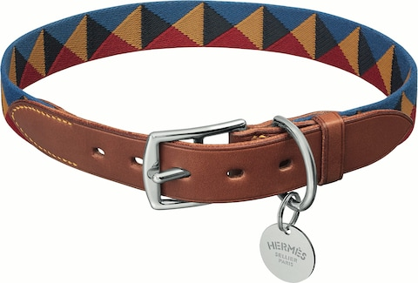
Hermes collar in webbing and bridle leather
Pagerie – the maiden name of the pug-loving Empress Joséphine – launched last October as an e-commerce store offering free international shipping on leather goods made by the same French artisans who craft handbags for Chanel. Founder Mandy Madden turned her back on a career in law for the life of an influencer and noticed that the women she met at fashion weeks were considerably better turned out than their canine companions.
Needless to say, Madden’s French bulldog Hector is the best-dressed hound in Los Angeles, whether wearing his Tascher lead (£383) or the Dórro collar (£280) which is Pagerie’s bestselling item. Like all four items in the current Sahara collection, the collar comes in an Instagram-friendly beige and arrives packaged in a cotton dust bag with a metal authenticity card.
But it’s not just the colour which has made the collar a hit with the likes of Miranda Kerr. “The Dórro has been such a showstopper because of its beautiful turn lock that allows you to put the collar on and take it off with a little snap, like a purse,” says Madden. “To be able to take Hector's collar off with one hand is a game changer.”
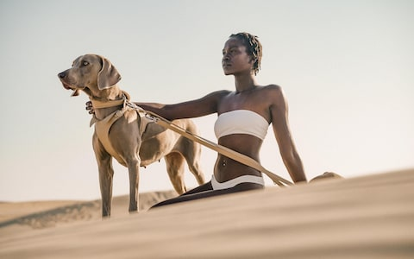
Pagerie is a high fashion brand for dogs
If you’re going to spend over £500 on a collar and lead, your dog needs to be well-groomed to match. Purplebone’s two Notting Hill salons are where Frank Lampard, Chloë Grace Moretz and the Beckhams take their pooches to get primped and pampered. Middle Eastern royalty drop off their dogs in the summer months while wealthy Russians fly their pets over on private jets. No surprise, then, that owner Jacob van Nieuwkoop is in talks to open a pop-up on Bond Street.
The most popular treatment is a full groom, which costs around £70 depending on dog size, and while coat colouring and painting dogs’ nails is definitely not on the salon menu (despite frequent requests), head groomer Billy, who you might recognise from the BBC’s Pooch Perfect, has been known to do a mean mohawk.
Take your lockdown puppy in sooner rather than later, advises Purplebone’s customer care manager Olivia Irvine. “More owners than dogs now have separation anxiety and people have spent so much time with their puppy during lockdown that they are delaying getting their dog to its first appointment. We have customers bringing in dogs who are nine months old and have never been groomed because their owners are anxious about leaving them.”
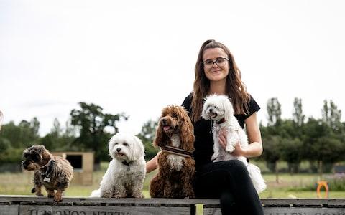
Emma White gained the nickname of Bo Peep because of the pack of small white animals trailing in her wake when she was a dog walker in Kensington Gardens
To socialise these lockdown fur babies, Irvine recommends that her Royal Borough locals leave their dogs with Man’s Best Friend Kensington and Chelsea, which transports dogs from west London to a converted farm in Surrey for a day of fun and frolics (£42). Owners are sent Instagram stories throughout the day so they can see how their dogs are enjoying themselves and receive text updates on their behaviour.
“The dogs have access to agility courses, ball pits and paddling pools and we also try and involve them in activities like scent games,” says founder Emma White, who gained the nickname of Bo Peep because of the pack of small white animals trailing in her wake when she was a dog walker in Kensington Gardens. “But to be perfectly honest, most of the dogs just love to play with their friends.”
Never mind man’s best friend: Barney returned from his first day with new BFFs Oliver the Fox Terrier and Dakota the Cockapoo and, best of all, slept for the rest of the evening on the floor.
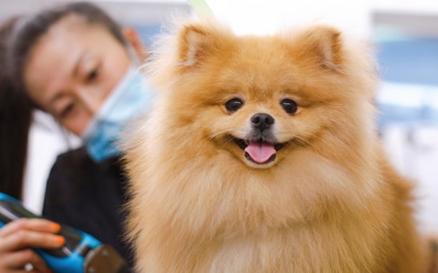
Purplebone operates two Notting Hill salons
If you’d prefer your dog didn’t slum it at your feet, however, consider the Dog Bed Settee from Howe. Designer Christopher Howe encountered the original when he was viewing his future house, Newark Park. The sofa was on the landing of the 16th-century Cotswold manor and obscured by a pair of happily dozing Great Danes.
The sofa left Newark Park with its previous tenants but Howe has recreated it for dog owners who would rather their pets had their own dedicated place to chillax. “It has to be covered in a dog-proof fabric like canvas or an old army tarp that is durable and self-cleaning,” Howe says.
“It’s not as if humans aren't allowed to sit on it, but it shouldn’t be turned into just another sofa.” Each settee is made to order for around £11,000. If your budget doesn’t stretch that far, Howe crafts dog beds that look like large cushions for £462.
Cat people, of course, will say that eleven grand for a sofa covered in stained tarpaulin is barking mad. But if this is what a dog’s life looks like, I want to be reincarnated with four legs and a lifetime’s supply of caviar.

https://www.telegraph.co.uk/luxury/drinking-and-dining/would-feed-dog-caviar-rise-michelin-doggy-dining-extravagant/

